Name:
Period:

NAME___________________________________________
Unit 3
Conception, Pregnancy and Labor and Delivery

STRAND 3 Students will identify characteristics of prenatal care, pregnancy and childbirth

Standard 2 Explain the characteristics of pregnancy.
b) Explain ovulation and conception. (ovum, ovary, fallopian tubes, uterus, endometrium, cervix, vagina, fertilization)
c) Identify the early signs and symptoms of pregnancy.
d) Identify common discomforts occurring during pregnancy.
e) Identify potential pregnancy complications. (toxemia/pre-eclampsia, miscarriage, stillbirth, premature, low birth weight, etc.)

Standard 3 Discuss the importance of early and on-going prenatal care.
- Identify the role of appropriate medical care, nutrition, weight gain, and other lifestyle choices on prenatal development.

Standard 4 Identify characteristics of prenatal development.
a) Outline the stages occurring during prenatal development. (zygote, embryo, fetus)
b) Define and discuss prenatal terminology. (umbilical cord, placenta, amniotic fluid, amniotic sac, uterus)
c) Identify the prenatal development occurring during each trimester.
d) Discuss multiple births. (identical, fraternal, conjoined, etc.)

Standard 5 List the sequential events in the childbirth process.
a) Define childbirth terms. (show, crowning, episiotomy, etc.)
b) Outline the three stages of labor.
c) Discuss delivery options. (vaginal, natural, with epidural, c-section)
d) Describe possible complications that may occur during childbirth. (breech, placenta previa, Rh factor, STDs, toxemia/pre-eclampsia, etc.)

PERFORMANCE OBJECTIVE #3
Identify at least four critical components of prenatal care (nutrition, folic acid, drugs, alcohol, tobacco, medical care, etc.) and explain the effects of each component (good or bad) on the developing fetus

UNIT 3 BELL QUIZZES
Unit 3 Bell Quiz #1 Prenatal Development Part 1  1. The waxy protective covering on the fetus’ skin is:  A. Quickening  B. Vernix  C. Lanugo  D. Lightening  2. Which is the correct order of prenatal development?  A. Zygote, Fetus, Embryo  B. Zygote, Embryo, Fetus  C. Fetus, Embryo, Zygote  D. Embryo, Zygote, Fetus  3. Which is a common symptom of pregnancy  A. Increased energy  B. Decreased vaginal discharge and heavy bleeding  C. Persistent headache and blurred vision  D. Frequent urination and sore breasts  4. Prenatal period lasts about  A. 26 weeks  B. 36 weeks  C. 40 weeks  D. 50 weeks  5. During which trimester does the majority of physical development occur?  A. 1st  B. 2nd  C. 3rd  D. They are all equal | Unit 3 Bell Quiz #2 Prenatal Development Part 2  1. Slight fetal movements called quickening are first felt by the Mom in which trimester?  A. 1st C. 3rd  B. 2nd D. 4th  2. A complication of pregnancy often characterized by a sudden weight gain and high blood pressure is:  A. Rh Factor  B. Gestational Diabetes  C. Toxemia / Pre-eclampsia  D. Placenta Previa  3. Which of the following guards against jolts, keeps the fetus at a constant temperature, and keeps fetus from forming adhesions to the uterine wall?  A. Placenta  B. Amniotic Fluid  C. Umbilical Cord  D. Womb  4. Which trimester is physically the most demanding for pregnant woman?  A. 1st  B. 2nd  C. 3rd  D. They are all equal  5. Doctors recommend that woman gain _________ pounds during pregnancy.  A. 10 - 15 lbs  B. 14 - 20 lbs  C. 24 - 30 lbs  D. 24 - 40 lbs
Unit 3 Bell Quiz #3 Labor and Delivery  1. What stage of labor is the placenta or afterbirth expelled?  A. 1st C. 3rd  B. 2nd D. 4th  2. What is the purpose of contractions during the 2nd stage of labor?  A. To expel the placenta  B. To break the amniotic sac  C. To widen the vaginal opening  D. To push the baby out  3. Which is the longest stage of labor?  A. 1st C. 3rd  B. 2nd D. 4th  (#4 and 5  ) | 4. What is the term called when a fetus is being expelled from uterus?  A. Episiotomy  B. Labor  C. Delivery  D. Epidural  5. With the Caesarean method of childbirth:  A. Mother has the main influence in deciding whether the child can be delivered by this procedure or vaginally.  B. Baby is delivered through an incision in abdomen and uterus  C. Birth takes place in a birthing room  D. Recovery for Mom is faster than after a vaginal delivery
Bell Quizzes #4 Stages of Prenatal Development

A. Period of the zygote / ovum B. Period of the embryo C. Period of the fetus

___ 1. The fertilized egg is about the size of a pinhead.
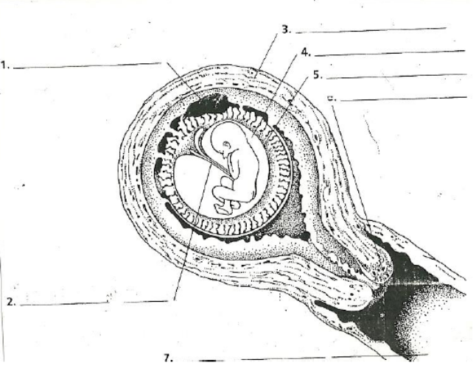
___ 2. The baby begins to add fat beneath the skin.
___ 3. A sac of amniotic fluid forms.
___ 4. The baby assumes the fetal position.
___ 5. The baby begins to move ‘quickening’ occurs.
___ 6. The fertilized egg passes through the Fallopian tube.
___ 7. Bones and organs begin to form.
___ 8. Conception takes place.
___ 9. The heartbeat can be heard through a stethoscope.
___ 10. The face and limbs begin to take shape.
___ 11. The fertilized egg attaches itself to the lining of the uterus.
___ 12. The baby is upside down, with its head nestled in the mother’s pelvis.
___ 13. The unborn baby begins to suck its thumb, cough, sneeze, and yawn.
___ 14. The fertilized egg begins to grow by the process of cell division.
___ 15. Nourishment begins to pass from placenta through the umbilical cord.
___ 16. Baby has Lanugo and vernix covering the body.
___ 17. Lightening occurs. Draw a line to the diagram that represents each stage.
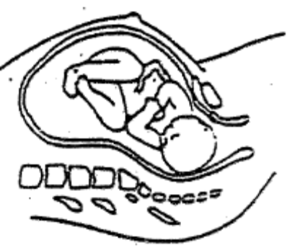
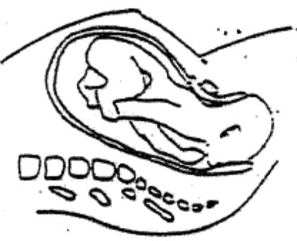
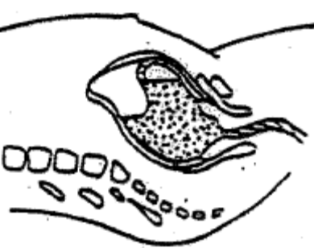
Bell Quiz #5 Stages of Labor
A. First stage B. Second stage C. Third stage

___ 1. Involves little or no discomfort.
___ 2. Episiotomy may be performed.
___ 3. Medication may be given to reduce discomfort.
___ 4. At the beginning of this stage, contractions are about two to four minutes apart.
___ 5. Relaxation is important to prevent muscles from tightening.
___ 6. Mother may be asked to bear down to help the baby along.
___ 7. Lasts from two minutes to half an hour.
___ 8. Baby moves down into lower pelvis and into position for birth.
___ 9. Baby is born.
___ 10. Near the end of this stage, contractions are strong and frequent.
___ 11. Longest stage of labor.
___ 12. Mother may be moved from the labor room to a separate delivery room.
___ 13. Uterus contracts to expel afterbirth (placenta, umbilical cord, amniotic sac).
___ 14. Cervix dilates and becomes thinner.
___ 15. Forceps may be used, if necessary.
___ 16. Crowning occurs.
___ 17. The show can be seen.
Unit 3 Conception, Pregnancy and Labor and Delivery

SECTION A: Pre-Natal Development
Standard 2: Explain the Characteristics of Pregnancy

- REVIEW: An O_______________ releases and O____________ (egg) during O_______________ (menstrual cycle). The fimbrae bring the egg into the F_____________________ T________________. If a S_________________ is present in the fallopian tube, then F_____________________ can take place. Fertilization must take place in the F_______________________ T__________________. Only one S_______________ may penetrate the O________________. If more than one ovum is present, they may both be FER____________________ and this will cause multiple births. A fertilized ovum will implant itself in the U__________________________ and Endometrium l_____________________________ and begin to develop.

2. What are 3 common signs and symptoms of pregnancy?

Standard 4: Identify the characteristics of prenatal development

3. What is pre-natal development and How long is it?

4. Prenatal Development is divided up into 3 trimesters explain each one and the related terms.
A. First Trimester:

 This trimester is the greatest time of risk and vulnerability for ________________________to the developing fetus.
Be careful with medication, environment, and lifestyle choices.

B. Second Trimester:

Quickening

Lanugo

 This trimester is physically the __________________________________________on the Mom

C. Third Trimester:

Vernix

Lightening

 This trimester is physically the most _______________________________ on the Mom.

5. Describe the 3 names of the baby and length during prenatal development
Zygote

Embryo

Fetus

6. Explain the parts of the “house” that the fetus lives in during prenatal development
Uterus/Womb

Amniotic Sac

Amniotic Fluid

Placenta

Umbilical Cord

7. A pregnant Mom should gain _________________________ lbs over the course of the entire pregnancy.
Explain 3 basic nutrition guidelines for the Mom to follow throughout pregnancy.

ASSIGNMENT #1: MOTHER TO BE MENU

Plan an appropriate 1 day menu for a pregnant woman. Cut out pictures, Draw, or write foods that will represent a well-rounded meal for Breakfast, Lunch, and Dinner. OBSERVE THE FOOD GUIDE PYRAMID.

BREAKFAST | LUNCH | DINNER

Why is this a healthy meal for pregnancy? How does it follow the FOOD GUIDE PYRAMID and other nutrition guidelines?

Standard 3 Discuss the importance of early and on-going prenatal care.

Sec B: Pregnancy Complications and Prenatal care
Standard 2e. Identify potential pregnancy complications and danger signs

Pregnancy  Complication | Symptoms and Danger Signs | Possible cause of the complication | Possible effects  on Mom | Possible effects  on Baby
Gestational Diabetes

Low Birth Weight

Placenta Previa

Premature

Preterm Labor

Rh Factor

Stillbirth

Spontaneous Abortion / Miscarriage

Toxemia /
Pre-Eclampsia

A. PROFESSIONAL CARE for PREGNANCY

- At the initial pre-natal exam, what are 6 routine exams that are done?

- Why is a doctor’s care important throughout the pregnancy?

- How often does a pregnant person receive a checkup?

- A mother’s body is the baby’s environment during a time of important development. Thus, a mother’s characteristics and health practices greatly affect the health of the baby. In the following list, mark a plus sign in front of maternal traits or health practices that help and unborn baby’s health. Mark a minus sign front of those practices that are harmful.

Sleeps well into the night and takes  naps during the day | Has high-pressured job that causes  various stress reactions | Mom has a different Rh factor  than the baby
Has not had rubella or the  vaccination | Is very underweight | Has dental check-ups
Relaxes in a hot tub | Makes poor meal choices | Exercises by walking or  swimming
Avoids even over the counter drugs | Smokes moderately | Is anemic – low iron
Happy and content with life in  general | Eats foods high in vitamins and  Minerals (calcium, folic acid, iron) | Is over age 36 years of age

Choose 2 health practices above and explain why this helps or harms the unborn child:

B. PERSONAL and EMOTIONAL CARE DURING PREGNANCY

1. What causes emotional changes during pregnancy?

2. How can a spouse and couple deal with the mood swings and postpartum depression of the pregnant wife?

3. Give 3 guidelines for personal prenatal care such as: rest, exercise, hygiene

4. Give 3 guidelines for choice of clothes and shoes during pregnancy

C. POSTNATAL NEEDS (After the baby is born)

1. Provide advice for meeting the new Mom’s needs for: rest, exercise, nutrition, and Medical Checkups
Rest

Exercise

Nutrition

Medical Checkups

2. What are “baby blues” or postpartum depression? What should a new Mom and Dad do about them?

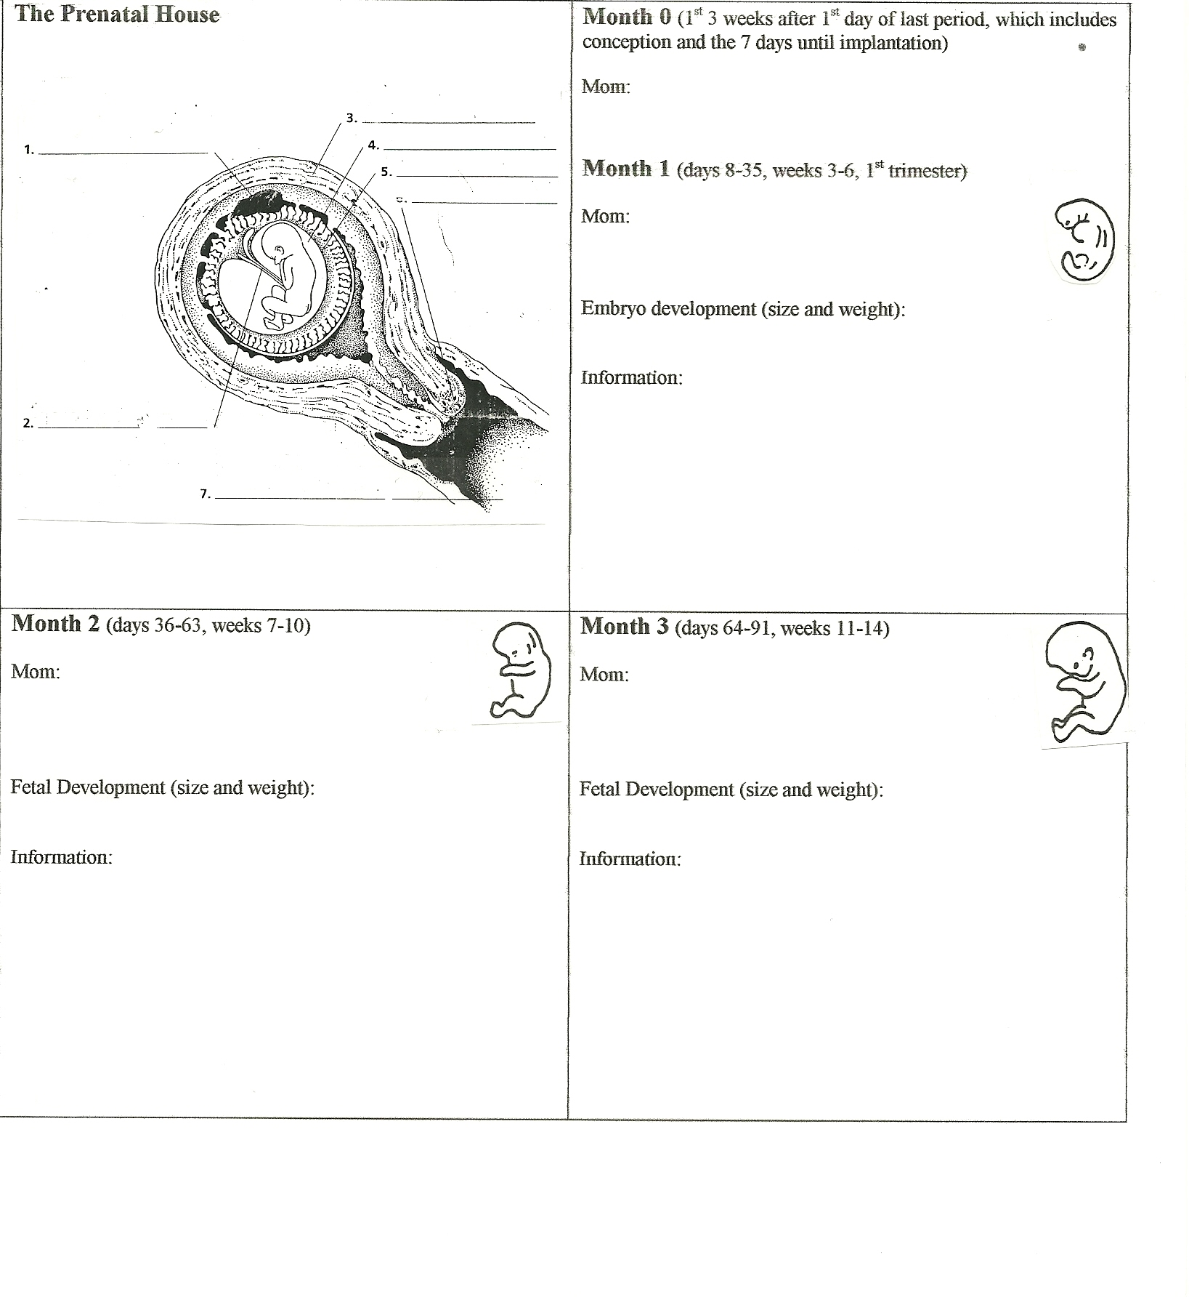
MONTH AT A TIME pg 1
Use the resources around the room to complete this prenatal development information.
Explain what is happening to the Mom, the Baby, and basic prenatal information.

MONTH AT A TIME pg2
Use the resources around the room to complete this prenatal development information.
Explain what is happening to the Mom, the Baby, and basic prenatal information.

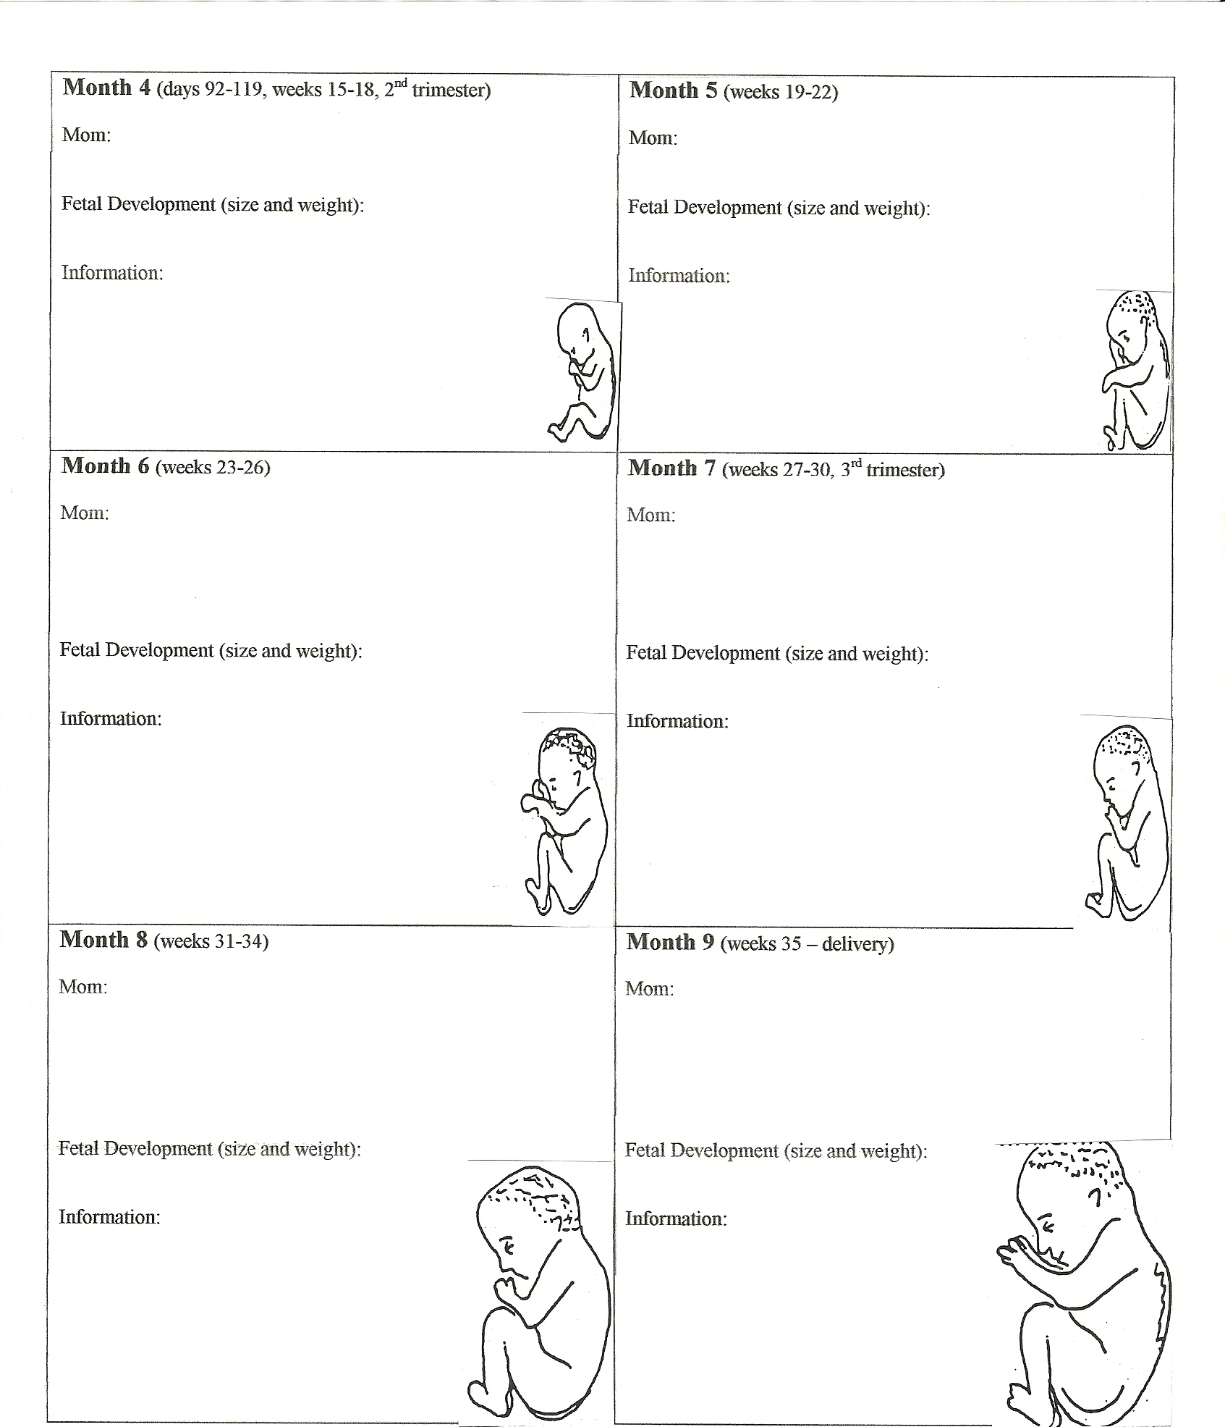

FATHERHOOD QUESTIONS

Answer the following questions based on your experiences with your Dad or another father figure in your life.
Think about the kind of father you want to be or to have for your own children.

- Describe your most positive, memorable, one-on-one activity with your father or father figure.

- Describe your most positive, memorable, family activity which included your father or father figure.

- Name 3 one-on-one activities you consider important for a father to do with his children.
A.

B.

C.

- What types of family activities do you consider important for a father to participate in.

- Describe the communication patterns that are most familiar between you and your father or father figure.

- How do you think a father should communicate with his children?

- As a child, what ways did your father, or father figure, tell you that he loved you and accepted you?

- What ways do you think a father should demonstrate his love and acceptance for his children?

- What role did your father, or father figure, have in caring for your physical, emotional, moral, educational, and social needs?

Compare this to what your Mom did.

- What role should fathers have in caring for the physical, emotional, moral, educational, and social needs of their children?

- IF YOU ARE A MALE: What will you do to be a bigger and more active part of your children’s lives?

- IF YOU ARE A FEMALE: How will you help your husband to be a bigger and more active part of you children’s lives?

Section C: Labor and Delivery
Standard 5: List the sequential events in the childbirth process

- Identify possible signs that indicate the beginning stages of labor.

Braxton Hicks

Show

Water breaks

- Describe the 3 stages (length, events, contractions...) of Labor and Delivery.

- First Stage

Labor is: | Effacement
Dilation | Crowning
What is the purpose of contractions during this stage?

- Second Stage

Delivery / Expulsion is: | Forceps/Vacuum
Episiotomy | Fontanelles
What is the purpose of contractions during this stage?

- Third Stage

Afterbirth (name the parts) | Lochia

- Who are these people?

Obstetrician | OBGYN
Mid-Wife | - Labor and Delivery Nurse

- Explain delivery options and why these might be used.

Vaginal delivery | Cesarean Section delivery
Birthing Room | Operating Room

- Explain choices and types of Anesthesia

Natural | Epidural

6. Describe possible complications that may occur during childbirth: (umbilical cord, stress, heart rate...)

- Explain possible ways a baby can be positioned for birth.

Normal | Posterior
Breech | Transverse
Fetus doesn’t drop into position

8. What is an average birth weight of a full term healthy baby?

9. What is an average cost for a healthy pregnancy and delivery?

10. What is a new Mom’s primary physical need after childbirth?

DRAW and DESCRIBE the 3 STAGES of LABOR in a way that you will remember them

