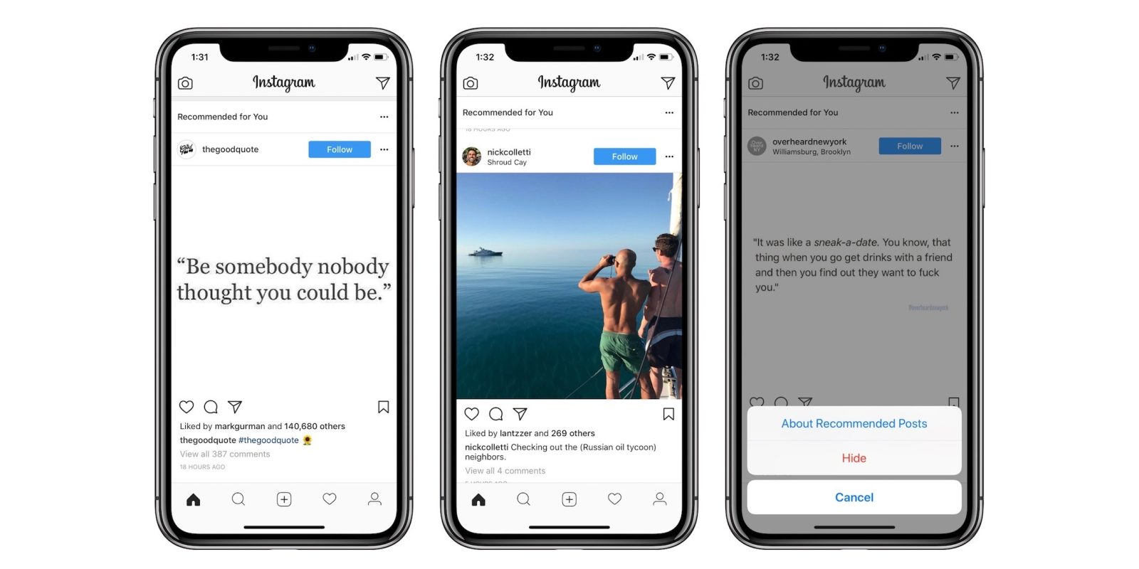



Name:

Period:

**Assignment:** Make one Instagram post for the demands of parenthood and one for the rewards of parenthood. Needs to include a picture, the post and hashtag, and be colored.