EARLY CHILDHOOD EDUCATION CURRICULUM 1A

Family and Consumer Science Department
Bingham High School Class Disclosure 2017-2018
Teacher: Mrs. Janae Dunn
School email: Janae.dunn@jordandistrict.org
Phone: 801-256-5100
Responsible Classroom Behavior:
Be responsible in regular attendance and completing assignments. Take responsibility for your personal learning. Be trustworthy and honest in doing your own work, and in your use of materials and equipment. Display good citizenship by participating in class and school activities. Show respect for the building and classrooms. Show respect for the flag and be an example to those around you. Show you care by being involved in your personal learning and consideration for your classmates. Always remember to treat others the way you would want to be treated.

A. Materials needed for class:
-Suggested: Pen, pencils, scissors, pencil box, binder
-$10.00 class fee for materials received. Pay in the main office and give receipt to Mrs. Dunn


B. Assignments:
-Assignments are expected to be typed or neatly written in ink
-Projects are to be worked on in class and submit by the due date
-Performance Objective projects are to be neatly prepared and on time

C. Homework is intended to supplement classroom instruction:
-Class assignments / activities
-Term projects (Early Childhood Educational Teaching File)

D. Late Work: A 25% penalty will be assessed on all late work, will be accepted until the end of the quarter.

E. Make-Up Work:
-It is the student’s responsibility to contact the teacher regarding make-up work
-The student has two class days after an absence to turn in work missed due to absence.
-Missed quizzes or tests must be taken before or after school, within 2 weeks of the absence.

F. Quizzes and Tests:
-A pretest will be given at the beginning of the semester and compared with the final post test.
-Quizzes may be corrected in class by fellow classmates.
-Unit tests will be given at the end of each unit of study.
-A State Competency Test will be given as part of the student's final grade.

G. Dress Code:
-District/School policy will be followed. Please review the policy at the district website at www.jordandistrict.org or the Bingham High web site www.binghamminers.org -Inappropriate dress will result in the student being escorted to the office and the student will miss class time.

H. Participation / Attendance:
-The award of credit in this class is subject to the conditions outlined in the BHS attendance policy. Absences in excess of 3 per class per quarter that are not made-up will result in loss of course credit. (NG). Please refer to the school attendance policy at www.binghamminers.org The definition of an absence is anytime the student is not in class for whatever reason. Pre-approved school activities (fieldtrips etc.) will NOT be penalized. Electronic devices used inappropriately are subject to confiscation.

I. Tardiness:
Tardiness disrupts the class and the tardy student misses valuable information or instruction. Being tardy means that you are not in your assigned chair when the bell rings. There will be no tardy make-ups during the last week of any quarter.

J. Grading Procedures:

Grading scale:
100-94% = A 75-73% = C
93-90% = A- 72-70% = C-
89-86% = B+ 69-66% = D+
85-83% = B 65-63% = D
82-80% = B- 62-60% = D-
79-76% = C+ 59 and lower = Failing

K. Classroom Rules:
Be prepared, follow instructions, be on time (in your assigned chair before the tardy bell rings), show respect at all times, and use appropriate language only.

Consequences of Rules

Positive
Individual Praise
Self-learning
Self Respect
Positive message home
Nominated for award

Negative
Warning
Seat change
Contact parents
Referral
Conference with Parents

L. Other Recommendations:
1. Check your grade online often so you know where you stand during the quarter. Inform me if clerical errors have been made.
2. Complete assignments promptly so as not to get behind.
3. Cell phones are not allowed in class and may be confiscated if being used, and picked up after class.
4. I will be available for consultation from 7:00 to 8:30am on A-days, and 1 to 3 pm on B-days. Please call for an appointment.
5. The Family and Consumer Science Department offers a club/chapter affiliation. The name of the club is FCCLA or Family, Career and Community Leaders of America. Benefits are many in the form of leadership and service opportunities, as well as making new friends and attending activities. You must be a member of FCCLA and meet the course requirements to qualify to receive a FACS / CTE cord to wear at graduation. Join soon to get a member tee shirt. Get involved!
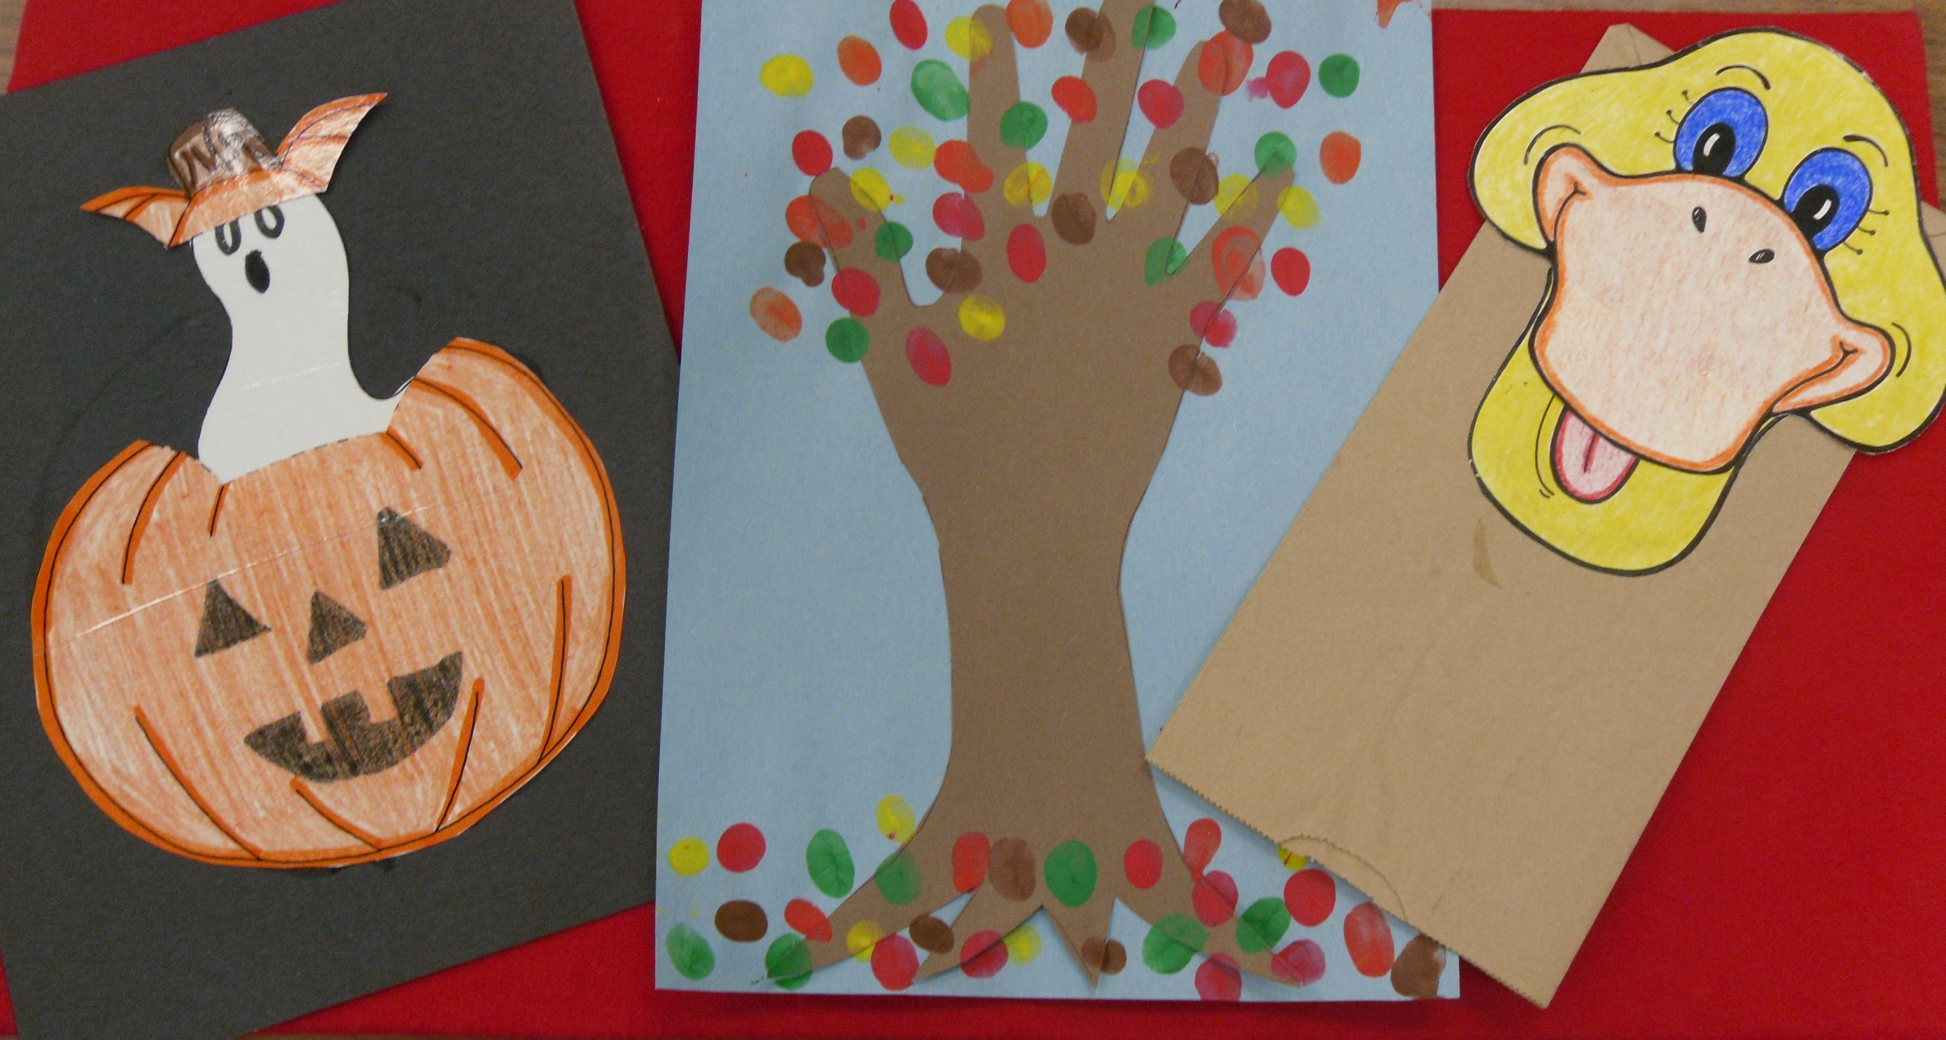

KEEP THESE PAGES AS A REFERENCE

PLEASE RETURN THIS PORTION OF THE DISCLOSURE!

Agreement to Abide by Early Childhood Ed. Curriculum 1A
Class Disclosure

Dear Students and Parents/Guardians:

At the beginning of the school year or semester it is desirable to establish polices or standards that will enable our classroom community to function and learn to the best of our abilities. It is my purpose in writing these policies to foster a classroom atmosphere of respect, responsibility, honesty, hard work, fairness, caring and above all, being a good citizen and a person of character. I will be happy to answer any questions you might have regarding classroom policies, or course content. I appreciate the opportunity to work with you and I am looking forward to a great year. Please sign below that you have read and will abide by the terms of this disclosure and return this portion to Mrs. Dunn. Keep the remaining portion for your reference.

Student Name: ________________________________________ Student Signature: _____________________________________________
(Please Print)

Parent Name: __________________________________________ Parent Signature: ______________________________________________
(Please Print)

Date: ______________________________________

Janae Dunn
Bingham High School
Family and Consumer Science Department
Phone: 801-256-5100
School email: Janae.dunn@jordandistrict.org

